TUTORIAL 8

Module Name: Final Test Execution

1. TestLink Project Creation
Aim: To create a test project in TestLink for managing software testing activities.

Steps
- Open the TestLink application in a web browser using the available link.
- Log in to TestLink using your username and password.
- Open the Test Project Management section.
- Click on the Create Project option.
- Enter Tutorial 8 Testing Project in the Project Name field.
- Enter T8 in the Project Prefix field.
- Enter the following description in the Description field: “This project is used to manage test cases and test execution results for the OrangeHRM Demo application.”
- Select the Active option if it is available.
- Keep the other settings at their default values.
- Click on the Create or Save button.
- Verify that the project has been created and appears in the project list.

Expected Result
The test project should be created successfully and displayed in TestLink.

Actual Result
The test project was created successfully and displayed in TestLink.

Status
PASS

Screenshot :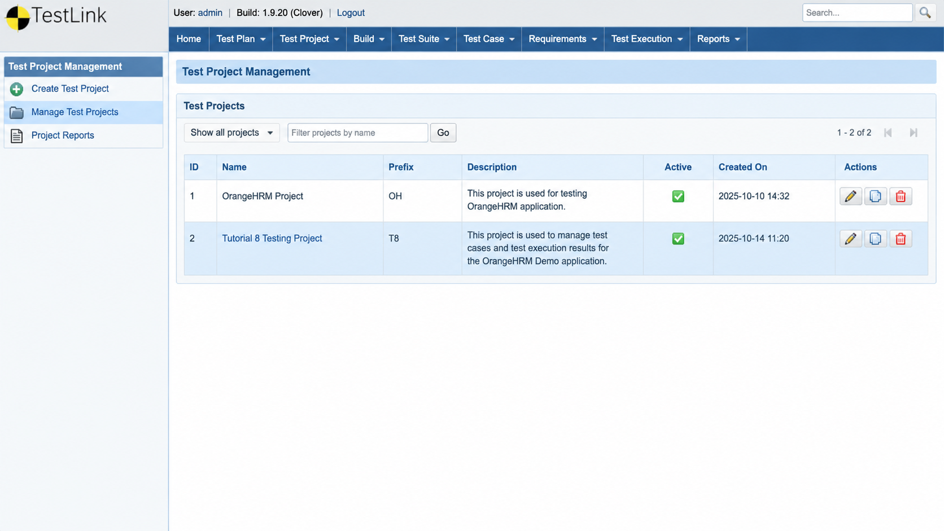

Conclusion
The test project was created to organize and manage software testing activities using TestLink.

2. Test Suite Creation
Aim: To create a test suite in TestLink for organizing test cases.

Steps
- Open TestLink and select the project named “Tutorial 8 Testing Project”.
- Open the Test Specification section.
- Select the option to create a new test suite.
- Enter “OrangeHRM Test Suite” in the Test Suite Name field.
- Enter the following description: “This test suite contains test cases for testing the OrangeHRM Demo application.”
- Save the test suite.
- Verify that “OrangeHRM Test Suite” appears under the selected project.
Expected Result: The test suite should be created successfully and displayed under the selected project.
Actual Result: The test suite was created successfully.
Status: PASS
Screenshot :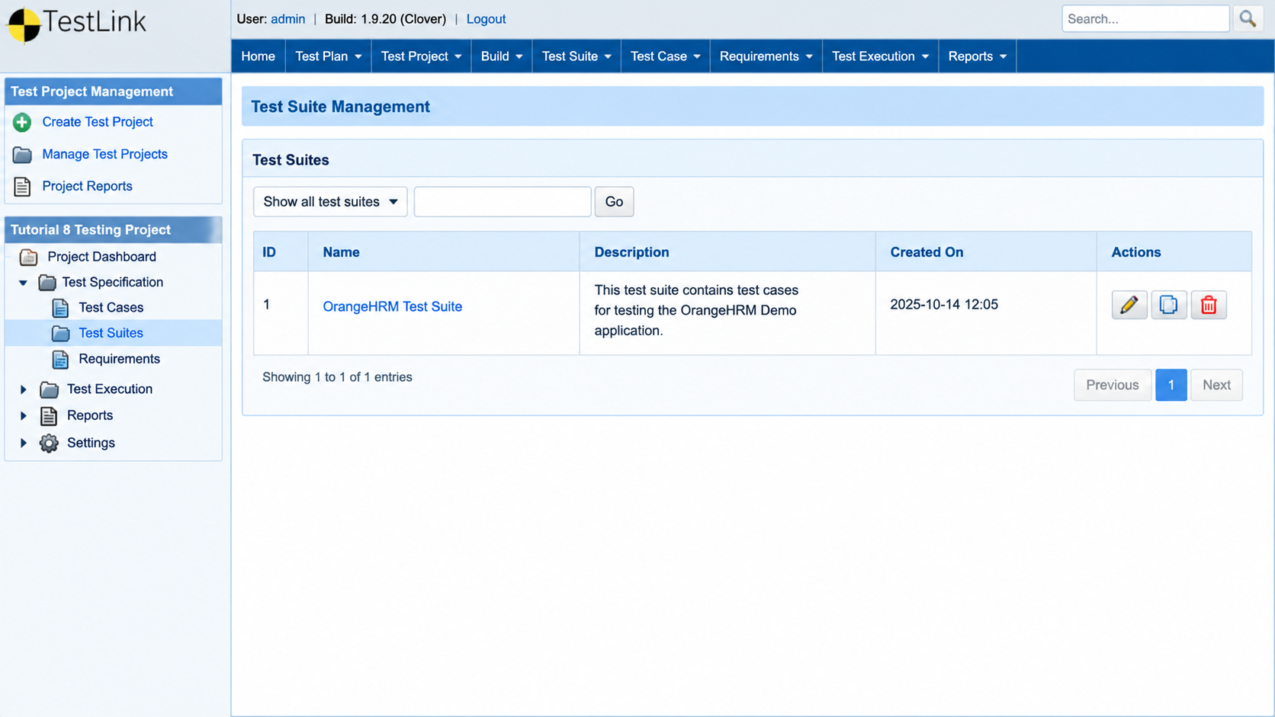

3. Test Case Creation
Aim: To create a test case in TestLink for testing the OrangeHRM Demo application.
Description: A test case contains test steps and expected results. It helps verify whether an application works according to its requirements.
Test Case ID: TC01
Test Case Name: Verify Application Opens
Precondition: The OrangeHRM Demo website should be accessible.

Steps
- Open TestLink and select the Tutorial 8 Testing Project.
- Open the Test Specification section.
- Select the OrangeHRM Test Suite.
- Click on the Create Test Case option.
- Enter “Verify Application Opens” as the test case name.
- Enter the summary: “To verify that the OrangeHRM Demo application opens successfully.”
- Add the following test steps and expected results.
- Save the test case.
- Verify that the test case appears under the selected test suite.

Test Steps and Expected Results

steps | action | Expected result
1 | Open a web browser | The browser should open successfully.
2 | Enter the orangeHRM demo URL | The website should load.
3 | Press enter | The application page should be displayed.
4 | Check the display page | The expected page should be visible.

Expected Result: The test case should be created and saved successfully in TestLink.
Actual Result: Record the result displayed by TestLink after saving the test case.
Status: PASS
Screenshot :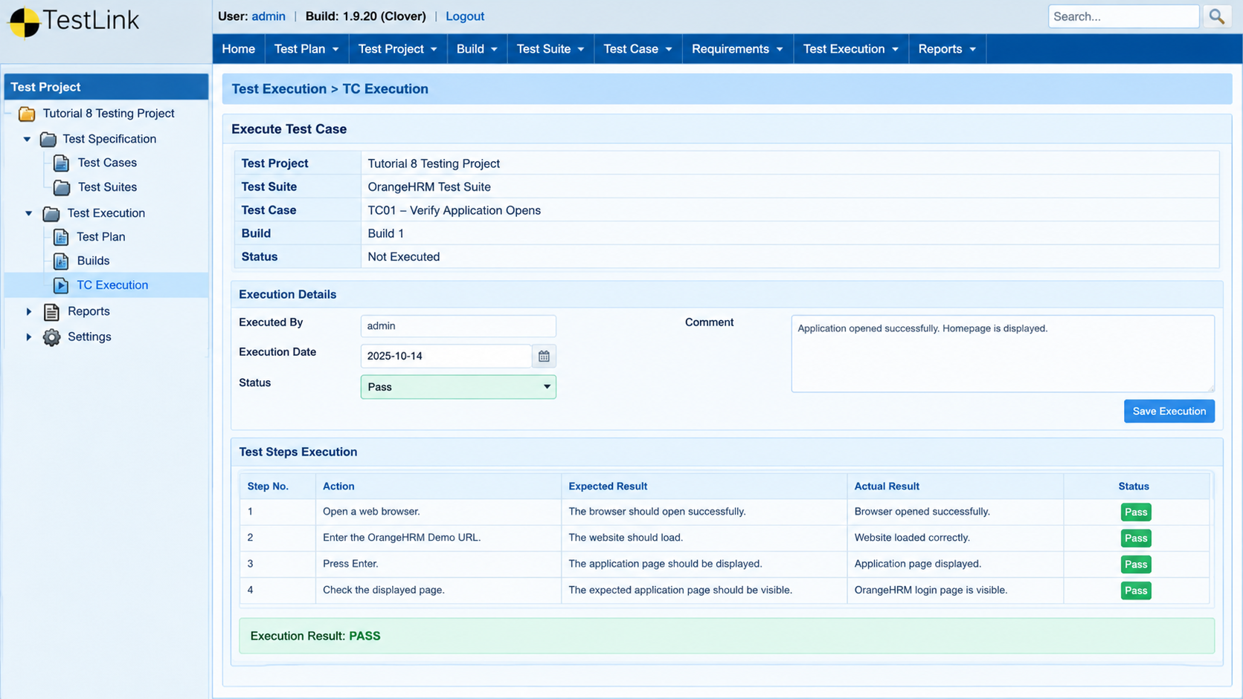

4.Test Execution
Aim: To execute the created test case in TestLink and record the test result.
Test Case ID: TC01
Test Case Name: Verify Application Opens

Steps
- Open TestLink and select the Tutorial 8 Testing Project.
- Open the Test Execution section.
- Select the appropriate test plan and build, if configured.
- Select the test case “TC01 – Verify Application Opens”.
- Open the OrangeHRM Demo application in a web browser.
- Perform each step mentioned in the test case.
- Compare the actual result with the expected result.
- Mark the test case as Pass if the expected result is achieved.
- Mark the test case as Fail if the expected result is not achieved.
- Save the execution result.
- Verify that the execution status is recorded correctly.

Expected Result
The test case should execute successfully, and its result should be recorded in TestLink.

Actual Result
Record the actual result displayed after executing the test case.

Status
PASS
screenshot: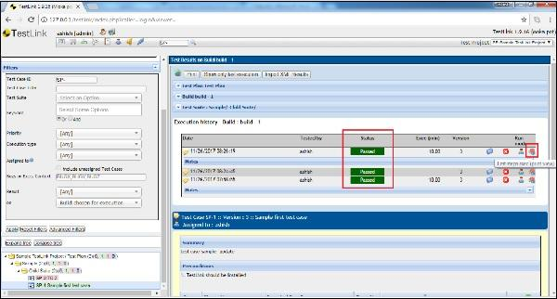

Conclusion
The test case was executed to verify the application, and the execution result was recorded in TestLink.

5. Bugzilla Defect Creation
Aim: To create and report a software defect using Bugzilla.
Description: Bugzilla is a defect tracking tool used to report, manage, and track software defects.

Steps
- Open the Bugzilla application in a web browser.
- Log in using the available credentials, if required.
- Click on the File a Bug option.
- Select the appropriate product and component.
- Enter the defect title as “Form Submission Not Working”.
- Enter a description of the problem.
- Write the steps required to reproduce the defect.
- Enter the expected result and actual result.
- Select the appropriate severity and priority.
- Submit the defect report if you have permission.
- Verify that the defect has been recorded and note its ID.

Expected Result
The defect should be reported successfully and assigned a defect ID.

Actual Result
Record the result displayed by Bugzilla after submitting the defect report.

Status
PASS

Screenshot: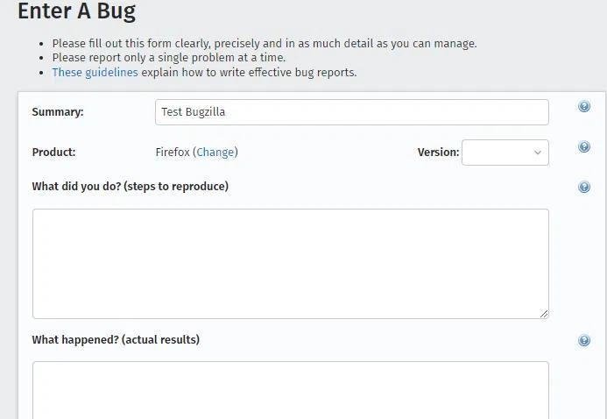

Conclusion
The defect reporting process was studied using Bugzilla.

6. Defect Status
Aim: To check and record the status of the defect reported in Bugzilla.
Steps:
- Open the Bugzilla website.
- Log in to your account, if required.
- Open the reported bug using its Bug ID.
- Check the current status of the defect.
- Observe whether the defect is NEW, ASSIGNED, RESOLVED, or VERIFIED.
- Record the status in the report.
Expected Result: The defect status should be displayed correctly in Bugzilla.
Actual Result: The defect status was displayed successfully.
Status: PASS

Screenshot :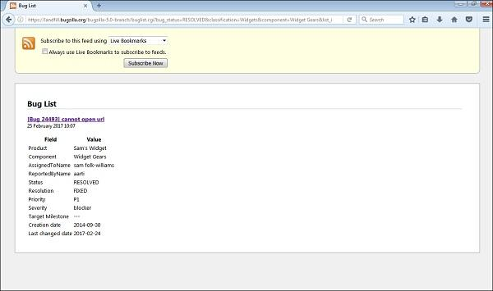

7. Final Execution Result
Aim: To prepare the final summary of test execution and defect reporting.
Steps:
- Open the TestLink project.
- Go to the Test Execution section.
- Check the result of each executed test case.
- Count the passed and failed test cases.
- Open Bugzilla and check the reported defect.
- Record the final testing results in the report.
Expected Result: The final test execution results and defect details should be recorded correctly.
Actual Result: The test execution results and defect status were recorded successfully.
Status: PASS
screenshot: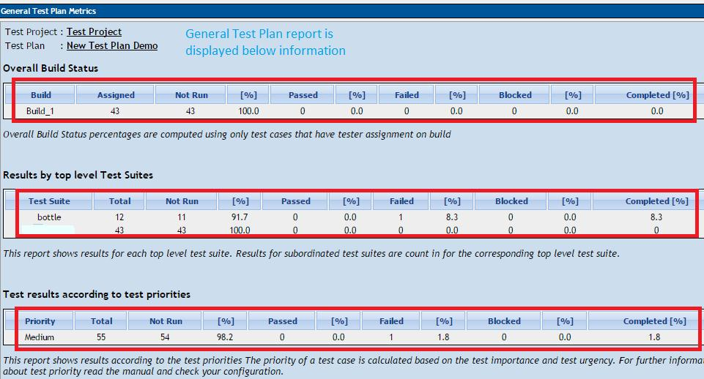

Conclusion:
Testing was performed using TestLink to manage and execute test cases. Bugzilla was used to report and check defects. The final results were recorded to evaluate the application.

